Application Number | 07/2018/0965/PAPTDE
Address | Telecommunications Mast  Hedgerows Road  Moss Side  Leyland  Lancashire
Applicant  Agent | Vodafone Ltd and CTIL  Mr Chris Taylor  Mono Consultants Ltd  Steam Packet House  76 Cross Street  Manchester  M2 4JG
Development | Application for prior notification of  telecommunications for the installation of a 15m dual user monopole accommodating 3no shrouded antennas and 2no. 300mm transmission dishes with 1no equipment cabinet
Officer Recommendation Officer Name | Prior approval not required Mrs Catherine Lewis
Date application valid | 15.02.2018
Target Determination Date | 12.04.2018
Extension of Time N/A
Illustrative purposes only
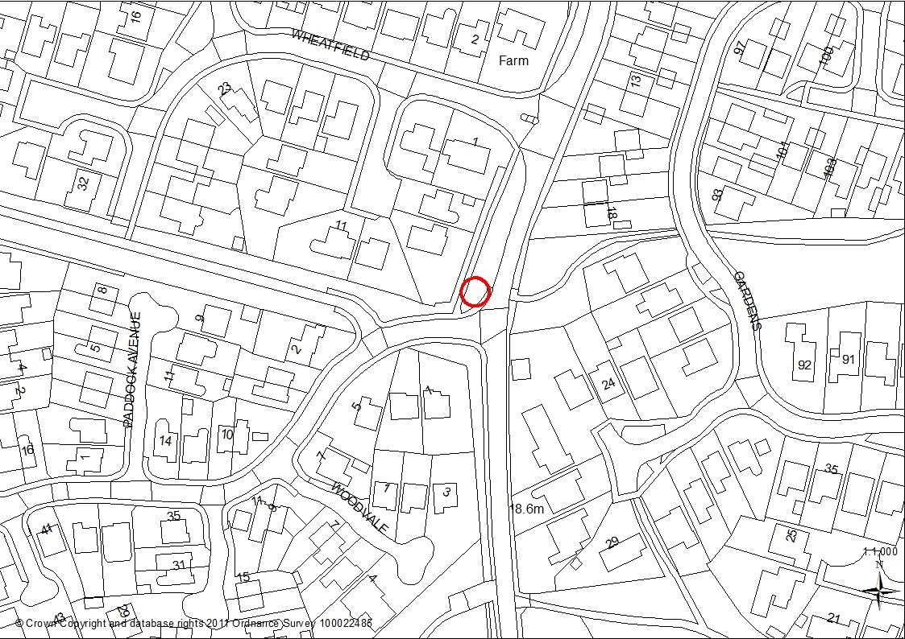

1.0 Report Summary
1.1 This application is for prior notification under part 16 of the Town and Country Planning (General Permitted Development) (England) Order 2015 and is not a planning application. The legislation gives Local Planning Authorities 56 days to consider whether the siting and design of a particular proposal is acceptable. The legislation does not provide for the consideration of the full implications of the particular development as would be the case with an application for planning permission.
1.2 An ICNIRP Compliance Declaration has been submitted. All applications for planning permission or prior approval are required to be accompanied by a signed declaration that the equipment and installation has been designed to be in full compliance with the requirements of the radio frequency public exposure guidelines to the International Commission of Non Ionizing Radiation Protection.
1.3 An application for a 15metre dual user monopole accommodating 3 no shrouded antennas 2 no transmission dishes and 2 no equipment cabinets and 1 metre ancillary pillar on the grass verge on the corner of School Lane and Hedgerows Road was refused by the Planning Committee in February 2016. The applicant decided to appeal the decision and the Planning Inspector allowed the appeal in October 2016.
1.4 The scheme was implemented but the monopole was constructed 2m away from the position allowed at appeal. The Council requested that this situation was remedied through the submission of an application and at that stage there was the opportunity to reconsider the location of the monopole. Following consultation with the neighbours the current application proposes the monopole some 8.5metres south from the scheme allowed at appeal.
1.5 The proposed location adjacent to the corner of Hedgerows Road and School Lane would ensure that the amenities of the properties known as No 5 and 7 Wheatfield which directly abut the public footpath would be more protected. Given the benefits of mast sharing within this tightly constrained estate, the impact of the equipment within the street scene and upon residential amenity, is considered limited and acceptable in the context of the street scene.
1.6 It is therefore recommended that no further details are required and the applicant be allowed to construct the equipment as permitted development.

2.0 Site and Surrounding Area
2.1 The site is located on a grass highway verge on the corner of Hedgerows Road and School Lane, Moss Side, Leyland- a predominately residential area. Adjacent to the junction with Hedgerows Road and School Lane the telecommunications equipment would be located in between a pedestrian footpath and the main road. The rear and side garden of the property known as no 7 Wheatfield backs on to the pedestrian footpath and is the closest residential property to the monopole. Other properties in close proximity include numbers 1, 5 and 9 Wheatfield and the properties directly opposite the site no’s 1, 2, 3 and 5 Hedgerow Road.
2.2 On the opposite side of School Lane to the application site, there is a small wooded area with a pedestrian footpath that runs through the housing development off St. James Gardens.

3.0 Planning History
3.1 07/2015/1846/PAPTDE The installation of a 15m dual user monopole accommodating 3no shrouded antennas and 2no 300mm transmission dishes with 2no equipment cabinets and 1no meter pillar. Refused on 24 February 2016.
3.2 The reasons for refusal were as follows “The proposed mast by virtue of its siting appearance and height would be a prominent and incongruous form of development which would fail to relate to the surrounding residential area. The proposed mast be virtue of its siting, appearance and height would unduly impact on the residential amenities of numbers 1, 5, 7 and 9 Wheatfield, Moss Side, Leyland.”
3.3 The applicant appealed the Decision Notice and the appeal was allowed by the Planning Inspectorate in October 2016 (APP/F2360/W/16/3148901).

4.0 Proposal
4.1 Adjacent to the junction with Hedgerows Road and School Lane the telecommunications equipment would be located on the grass verge and would be set 1metre from an existing lamppost on the main grassed verge. The proposal known as a base station involves the installation of a 15m dual user monopole to house three shrouded antennas which would be mounted together at the top of the structure. The main stem of the column would be cylindrical and would measure 324mm in diameter. At a height of 12.5 metres the monopole would increase in diameter to 540mm for a total of 2.5m to the top of the monopole. The mast would be goosewing in grey and constructed of galvanised steel.
4.2 There would be a further two pieces of equipment:
1 cabinet measuring 0.77m x 0.750 with a maximum height of 1.725m with a plinth - 700 x 703 x 200
1 metre pillar measuring 0.379mx 0.171m with a maximum height of 0.872mm.
This equipment would be painted fir green and be constructed of galvanised steel.
4.3 The applicant has advised that with regards these aspects of the scheme it is worth noting that the equipment cabinet and meter have a status of permitted development when seen against the parameters of Part 16 of the planning legislation. In their entirety, they are less than 2.5 cubic metres and so do not require a formal application or determination as it is permitted development. However for illustrative purposes they have been included in the drawings and description. In this regard the onus of the determination should focus on the siting and appearance of the monopole.
4.4 This is an application for Prior Notification under Part 16 of the Town and Country Planning (General Permitted Development) (England) Order 2015 and is not a planning application. This legislation gives Local Planning Authorities 56 days to consider if the siting and design of a particular proposal is acceptable but does not allow for consideration of the full implications of the development as would be the case with an application for planning permission.

5.0 Summary of Publicity
5.1 Site notices have been posted and a total of 69 properties have been consulted. Three letters of representation have been received. One expressing concern that the plans do not provide enough detail and two objecting to the scheme

5.2 Letters of objection
Two letters raising the following summarised points:
- The proposed location would impact upon the view from the rear garden and rear windows.
- More people would be affected by the revised location because the mast would be on the corner of Hedgerows Road and School Lane.
- The mast should be left where it is
- The mast will become a visible eyesore to people on Hedgerows Road and School Lane.
- Moving the mast will make the mast more visible to a greater number of residents in the area both upon St. James Gardens and Hedgerows Road.
- The Mast in the current location is partially screened from the residents on St. James by trees on the west side of School Lane.
5.3 Letters of comment
One letter raising concerns about the lack of information about the location of the Mast and would therefore need to object. The location has since been clarified and no objection is now raised.

6.0 Summary of Consultations
LCC Highways – no objections negligible impact upon highway safety, and capacity in the vicinity of the area.

7.0 Policy Background
7.1 National Planning Policy Framework (NPPF)
“Paragraph 42. Advanced, high quality communications infrastructure is essential for sustainable economic growth. The development of high speed broadband technology and other communications networks also plays a vital role in enhancing the provisions of local community facilities and services.
Paragraph 43. In preparing Local Plans, local planning authorities should support the expansion of electronic communications should support the expansion of electronic communications networks, including telecommunications and high speed broadband. They should aim to keep the numbers of radio and telecommunications masts and the sites for such installations to a minimum consistent with the efficient operation of the network. Existing masts, buildings and other structures should be used, unless the need for a new site has been justified. Where new sites are required, equipment should be sympathetically and designed and camouflaged where appropriate […]
Paragraph 46. Local planning authorities must determine applications on planning grounds. They should not seek to prevent competition between different operators, question the need for the communications system, or determine health safeguards if the proposal meets International Commission guidelines for public exposure.”

7.2 South Ribble Local Plan
7.2.1 Policy B1 Existing Built up Areas
“Within the existing built-up areas, as defined on the Policies Map, proposals for the re-use of undeveloped and unused land and buildings, or for redevelopment, will be permitted provided that the development:
- Complies with the requirements for access, parking and services, as set out elsewhere in this Plan;
- Is in keeping with the character and appearance of the area; and
- Will not adversely affect the amenities of nearby residents.”

7.2.2 Policy G17 Design Criteria of New Development, amongst other things, requires development not to have a detrimental impact on the street scene by virtue of its design, height, scale, orientation, proximity and use of materials.
8.0 Material Considerations

8.1 Principle of the Proposal
7.1.1 There are a number of telecommunication masts along School Lane and in 2016 an application to locate a mast near the corner of School Lane and Hedgerows Road was refused by the Planning Committee but allowed on appeal. Therefore, the principle of the siting of the mast in this area has been established through the appeals process.

8.2 Impact upon Residential Amenity
8.2.1 Following the appeal, the mast was constructed in the wrong location (approximately 3 metres north west) due to underground infrastructure issues. An application to regularise the situation was requested and as part of that process, the applicant has conducted discussions with the neighbours to seek to revise the location of the mast to reduce the impact upon the neighbours most affected namely no’s 1, 5, 7 and 9 Wheatfield.
8.2.2 The proposed mast would be located some 4.6m m from the rear boundary of no 7 Wheatfield on the grass verge on the corner of Hedgerow Road and School Lane. This revised location would mean that the mast would be opposite the properties known as 1, 3, and 5 Hedgerows Road. Two letters of objection have been received to this revised location which make the point that due to the corner location, more properties would now be affected.
8.2.3 It is acknowledged that the mast would be more visible due to the corner location however, there would be a separation distance of some 16 metres from the front gardens of these properties on Hedgerows Road.
8.2.4. The applicant has demonstrated that that there is a need for a mast in this location through the previous application. Although the revised location would increase the impact upon the residential amenities of the properties known as 1, 2, 3 and 5 Hedgerows Road these properties are further away from the proposed location of the monopole than no’s 1, 5 and 7 Wheatfield and on balance the proposed location is acceptable.
8.2.5 Concern has been raised that the proposed location of the mast would not benefit from the existing tree coverage and therefore the mast would be more visible to properties on St. James Garden. Whist this point is accepted there would be a separation distance of some 40metres from the proposed location to the rear garden of no 19 St. James Garden which is considered acceptable and not dissimilar to the existing situation experienced by other properties on School Lane near the Community Gardens. It is considered that the proposed location of the mast on the corner on Hedgerows Road and School Lane would not unduly impact the amenities of the adjacent residents or the street scene. The proposal, therefore complies with Policy B1 and G17 of the South Ribble Local Plan.
8.3 Highways
8.3.1 The applicant undertook pre application discussions with LCC Highways who confirmed that the revised location of the monopole was within the adopted highway and the location was acceptable. Initially, concern was raised about the proposed location of two cabinets and following advice to improve visibility for pedestrians and other footway user’s one cabinet is proposed. LCC Highways has raised no objection.

9.0 CONCLUSION
9.1 The principle of the location of the monopole has been established through the appeals process. The opportunity to re-site the monopole would reduce the impact upon the adjacent properties no 1, 5 and 7 Wheatfield. Although the revised location would increase the impact upon the residential amenities of the properties known as 1, 2, 3 and 5 Hedgerows Road these properties are further away from the proposed location of the monopole than no’s 1, 5 and 7 Wheatfield and on balance the proposed location is acceptable. The proposed location of the mast on the corner on Hedgerows Road and School Lane would not unduly impact the amenities of the adjacent residents or the street scene.
9.2 For the above reasons the proposal is deemed to comply with Policy B1 and G17 of the South Ribble Local Plan and the NPPF. It is therefore recommended that no further details are required with regards to the proposal allowing the applicant to construct the telecommunications mast and equipment as permitted development.
RECOMMENDATION:
Prior approval not required.

RELEVANT POLICY
NPPF National Planning Policy Framework
POLB1 Existing Built-Up Areas

POLG17 Design Criteria for New Development

